Tony’s Solution if you find anything incorrect, [@Liu, Taowen](mailto:tl2020@ic.ac.uk)

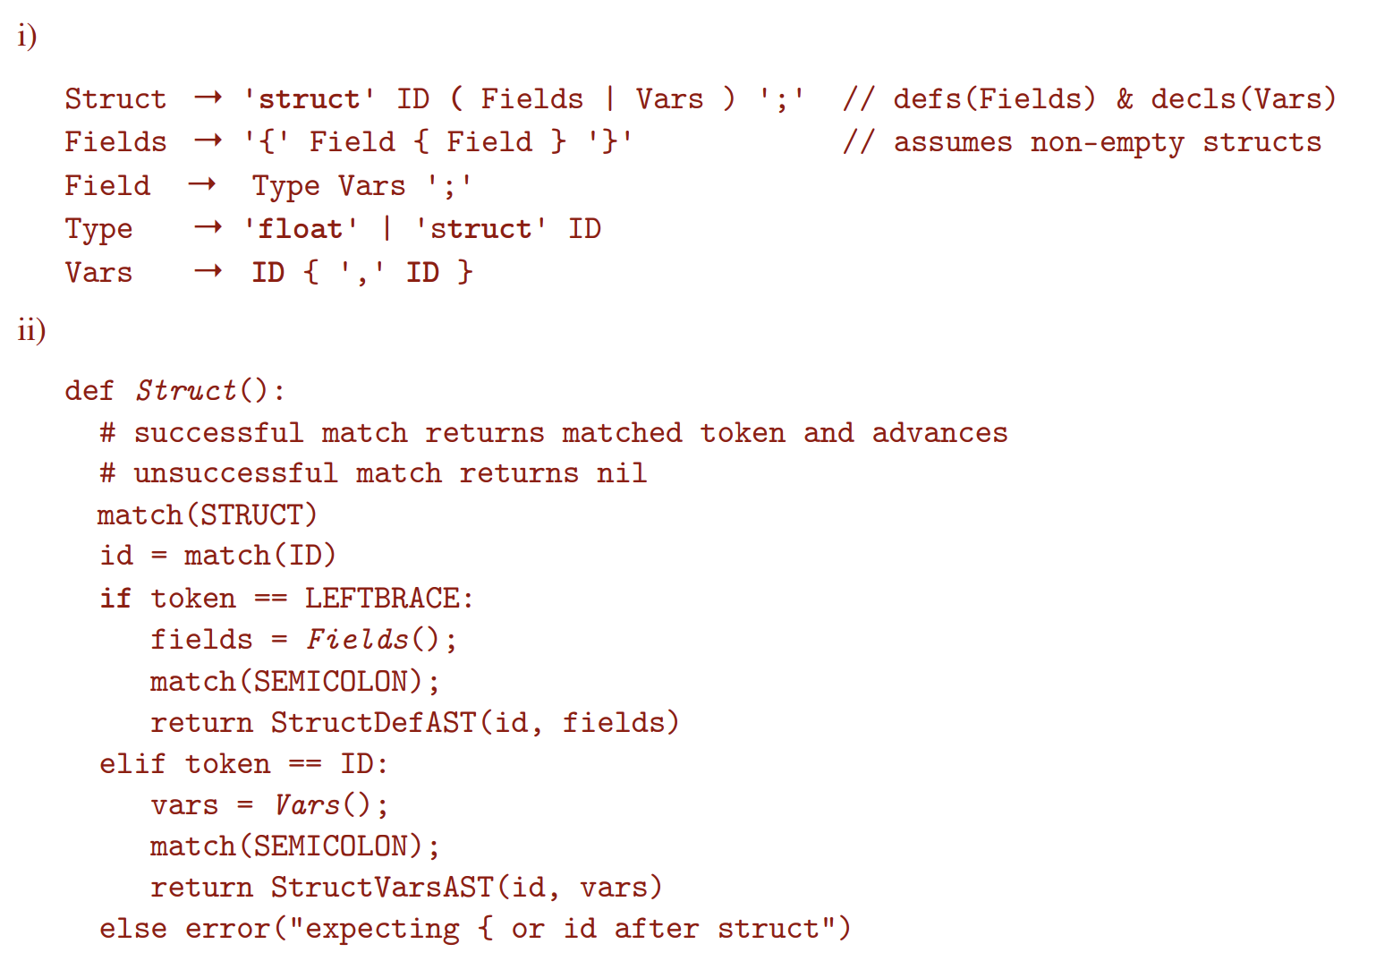

Struct -> 'struct' ID ('{' Fields '}' | Vars) ';'

Fields -> Field {Field}

Field -> Type Vars ';'

Type -> 'struct' ID | 'float'

Vars -> ID {',' ID}

def parseStruct() -> ASTNode:

match(STRUCT)

structName = token.get_id()

match(ID)

if token == ID:

vars = parseVars()

match(SEMI_COMMA)

return DeclareStructAST(structName, vars)

else:

match(OPEN_BRACES)

fields = parseFields()

match(CLOSE_BRACES)

match(SEMI_COMMA)

return NewTypeAST(struct_name, fields)

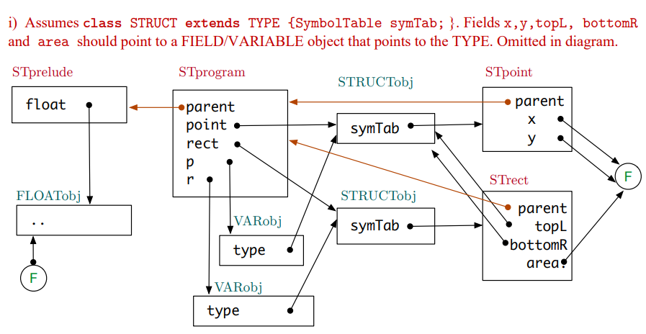

The semantic checker first look at the type of this statement, which is an assignment.

`r` is refered in LHS, it will check if it is in local scope (as a variable). Then it will check if it has attribute `.topL`. `r` has type `struct rect`, thus it has attribute `topL`. Expression `r.topL` has type `struct point`, then it has attribute `x`. `r.topL.x` has type float.

`p` is in local scope as a (variable). And it has type `struct point`. `p.y` has type float.

LHS and RHS has the same type.

Stack frame for get

Get.y

Get.x

r.area

r.bottomR.y

r.bottomR.x

r.topL.y

r.topL.x

Return address

Old frame-pointer (frame pointer)

Centre.y

Centre.x (stack pointer)

2. (I) only S3

(ii) S0, S1, S3, S4

(iii) there isn’t a natural loop inside the code

To see this, we just need to check if there is a header of a loop

For S0, S1, S2, S5 there is not instruction jump back to them

For S3, S5 can jump to S3, however S3 doesn’t dominate S5

For S4, S2 can jump to S4, but S4 doesn’t dominate S2.

b.

transCond :: Cond -> regs -> String -> [Intrs]

transCond (LessThan e1 e2) (r1:r2:rs) label =

transExp e1 (r1:r2:rs) ++

transExp e2 (r2:rs) ++

[Cmp (Reg r1) (Reg r2),

Blt label]

transDoWhile :: Stat -> regs -> [Intrs]

transDoWhile (DoWhile stats cond) (r1:r2:rs) =

[Define label] ++

concatMap (flip transStat (r1:r2:rs)) stats ++

transCond cond (r1:r2:rs) label

where

label = get_unique_label()

transContinue :: Stat -> regs -> [Intrs]

transContinue Continue _ = [Bra label]

where

label = get_current_end_loop_label()

transDoWhile' :: Stat -> regs -> [Intrs]

transDoWhile' (DoWhile stats cond) (r1:r2:rs) =

[Define label] ++

concatMap (flip transStat (r1:r2:rs)) stats ++

[Define curren_end_loop_label]

transCond cond (r1:r2:rs) label :

(misplaced label? Should be before transCond?)

where

curren_end_loop_label = create_current_end_loop_label()

-- there is an external state telling you what is the most inner end loop label when we have a nested loop

label = get_unique_label()